

《软件工程原理与应用》

系统设计报告

课程互动管理系统

|  |  |
| --- | --- |
| 小 组 | 001 B 周晨鸣 冉茂印 王晓栋 |
| 学院 | 计算机科学与技术学院/软件学院 |
| 专业 | 计算机科学与技术 |
| 班级 | 1623001 |

二〇二五年十一月

目 录

一、引言 1

1、编写目的 1

2、背景 1

3、定义 1

4、参考文献 2

二、界面设计 3

1、Student类 3

2、Teacher类 7

3、AcademicOfficer类 12

4、CourseInfo类 17

5、AssignmentInfo类 22

6、AssignmentAnswer类 23

7、Feedback类 24

8、Response类 27

三、事务逻辑设计 31

1、Student类 31

2、Teacher类 34

3、AcademicOfficer类 35

4、CourseInfo类 36

5、AssignmentInfo类 37

6、AssignmentAnswer类 38

7、Feedback类 40

8、Response类 41

四、数据库设计 42

1、 User类 42

2、 Student类 42

3、 Teacher类 42

4、 AcademicOfficer类 42

5、 CourseInfo类 42

6、 AssignmentInfo类 42

7、 AssignmentAnswer类 43

8、 Feedback类 43

9、 Response类 43

# 一、引言

## 1、编写目的

需求说明书目的是使用户和软件开发者双方对该软件有一个共同的理解，使之成为整个开发工作的基础。便于用户、开发人员进行理解和交流，反映出用户问题的结构，可以作为软件开发工作的基础和依据，并作为确认测试和验收的依据。

预期读者：软件设计者和测试者。

## 2、背景

说明：

1. 待开发的软件系统的名称：课程互动管理系统
2. 本项目的任务提出者：周晨鸣 冉茂印 王晓栋；
3. 本项目的任务开发者：周晨鸣 冉茂印 王晓栋；
4. 用户：需要使用课程管理、作业管理、及时反馈等功能的学生、教师和教务员。
5. 实现该软件的计算中心或计算机网络：南京航空航天大学计算中心。

## 3、定义

|  |  |
| --- | --- |
| 名称 | 说明 |
| 帐号 | 用户注册时登记并验证的手机号码 |
| 用户分类 | 分为学生、教师和教务员三类，每个帐号都有一个类别 |
| 用户信息管理 | 学生、教师和教务员都可通过该模块对用户信息进行增加、查询、修改、删除操作，分别对应注册、登陆、修改密码和用户信息、注销帐号 |
| 添加课程信息 | 教务员添加新的课程信息，录入课程名称、课程代码、授课教师、开课学期、课程描述、授课地点、上课时间、课程人数上限等信息。 |
| 查询课程信息 | 学生、教师和教务员可以查看所有课程信息，也可以通过多种筛选条件快速查询特定课程的详情。 |
| 修改课程信息 | 教务员对现有的课程信息进行修改，系统修改前会要求教务员确认，以防误操作。 |
| 删除课程信息 | 教务员可通过此功能将其信息从系统中删除。 |
| 修改作业信息 | 教师在作业截止前可以对已发布但未被学生提交的作业进行修改。 |
| 删除作业信息 | 教师可以删除自己之前布置的作业。 |
| 查询作业信息 | 学生和教师都可以查看已布置的作业信息。 |
| 课程信息修改 | 教务员可以对系统中现有的课程信息进行修改。 |
| 课程信息删除 | 教务员可以删除已停开或不再提供的课程信息。 |
| 提交答案 | 学生完成作业后，进行提交作业答案。 |
| 修改答案 | 学生在截至日期或教师批改前，可以修改自己之前的答案。 |
| 批改答案 | 教师在收到学生完成的作业答案后，进行批改，指出可能存在的错误，给予评价。 |
| 查询答案 | 学生可以查询自己的答案是否被老师批改，或者查看自己之前的答案是否存在不妥之处。 |
| 发布问题或反馈 | 学生在作业批改后，可以向老师提出问题或反馈。 |
| 查看问题或反馈 | 学生可以查看自己之前提出的问题或反馈，查看是否被老师解答。 |
| 修改问题或反馈 | 学生可以修改自己之前提出的问题或反馈。 |
| 删除问题或反馈 | 学生可以删除自己之前已提出的问题或反馈。 |
| 增加回答 | 教师可以回答学生作业下提出的问题或反馈。 |
| 查看回答 | 教师可以查看自己之前回答，学生可以查看教师给出的回答。 |

## 4、参考文献

|  |  |  |
| --- | --- | --- |
| 编号 | 参考资料 | 作者 |
| 1 | 《软件工程（第四版）》，高等教育出版社，2019 | 齐治昌等 |
| 2 | 《构建之法（第二版）》，人民邮电出版社，2015 | 邹欣 |
| 3 | 《Test-Driven Development with Python》，O'Reilly，2014 | Harry J. W |

# 二、界面设计

## 1、Student类

|  |  |
| --- | --- |
| signupStudent.html | 学生注册页面 |

web：

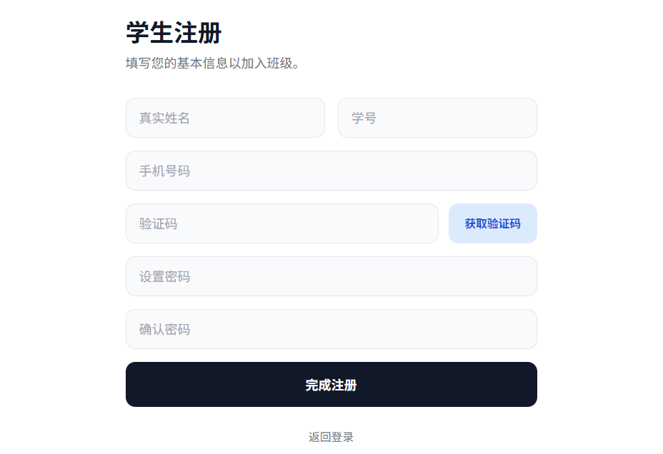

app:

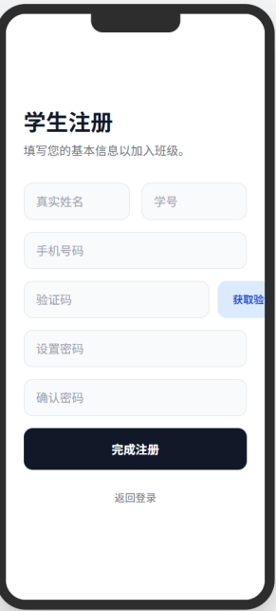

|  |  |
| --- | --- |
| signin.html | 登录页面 |

web:

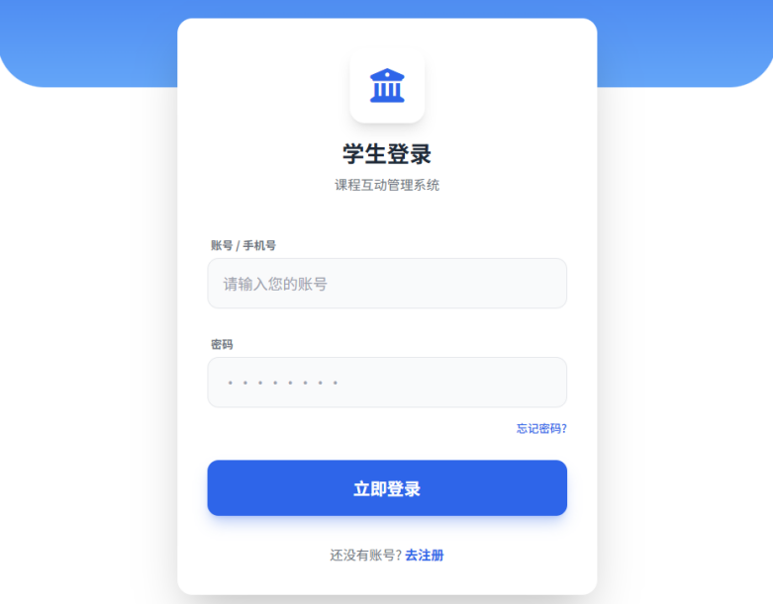

app:

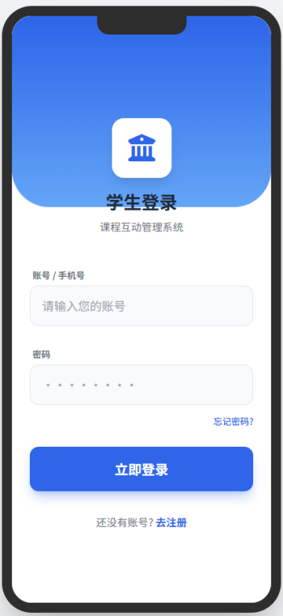

|  |  |
| --- | --- |
| index.html | 首页 |

web:

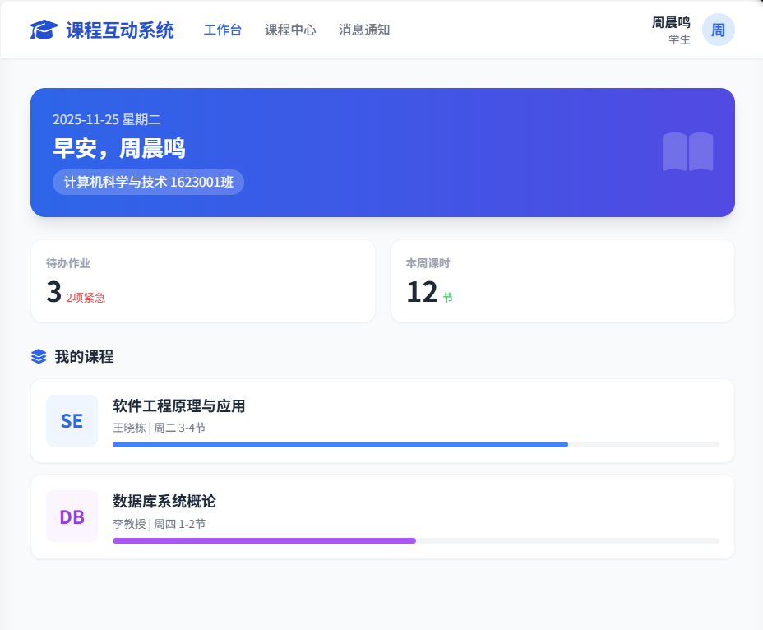

app:

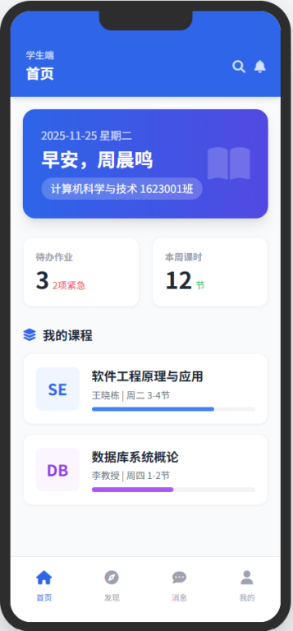

|  |  |
| --- | --- |
| getStudentInfo.html | 查看学生个人信息页面 |
| changeStudentInfo.html | 修改学生个人信息界面 |
| changePassword.html | 修改密码 |
| cancelStudent.html | 注销账户页面 |
| forgetPassword.html | 密码找回页面 |

web:

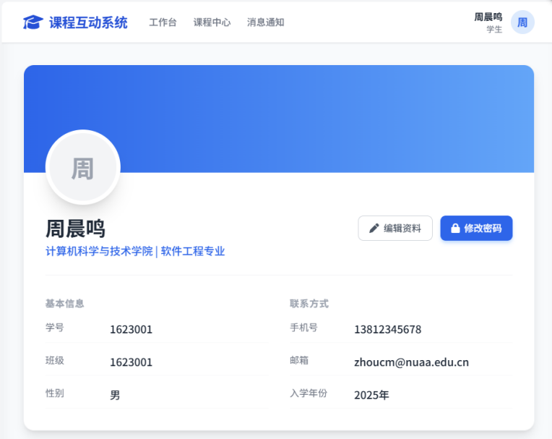

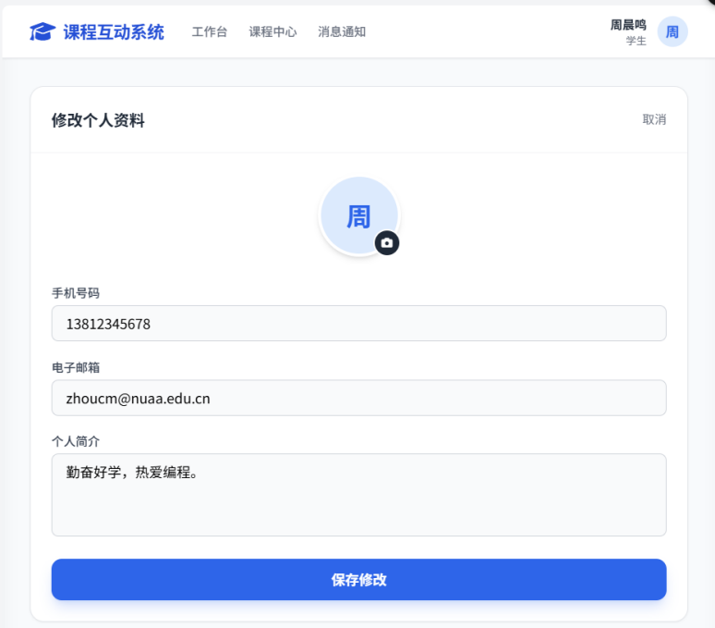

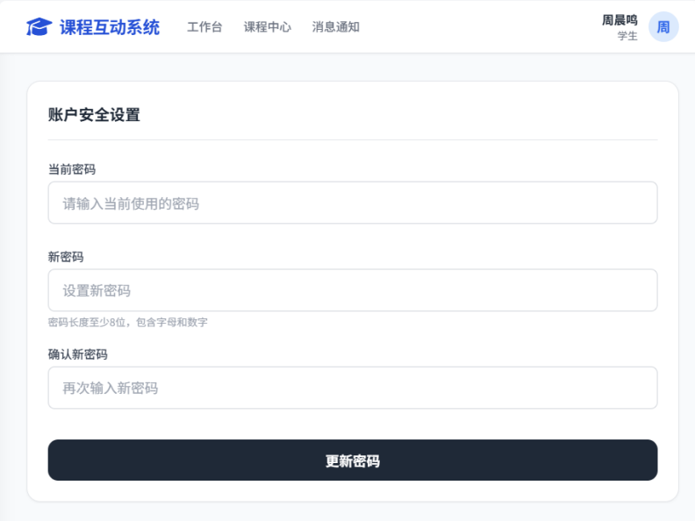

app:

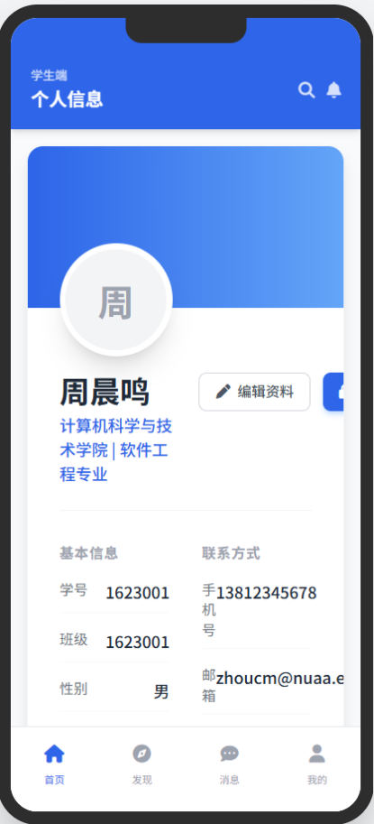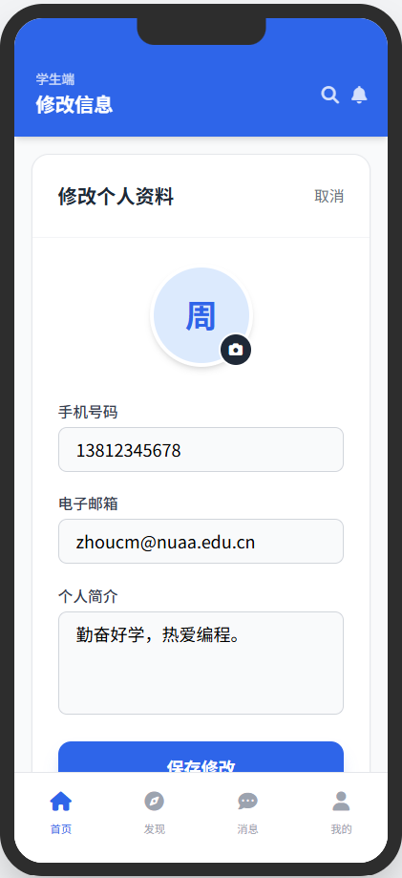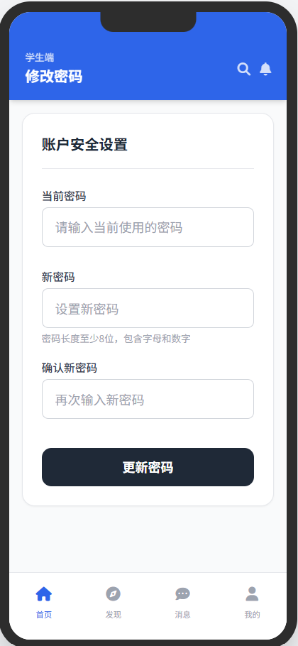

## 2、Teacher类

|  |  |
| --- | --- |
| signin.html | 登录界面 |

web:

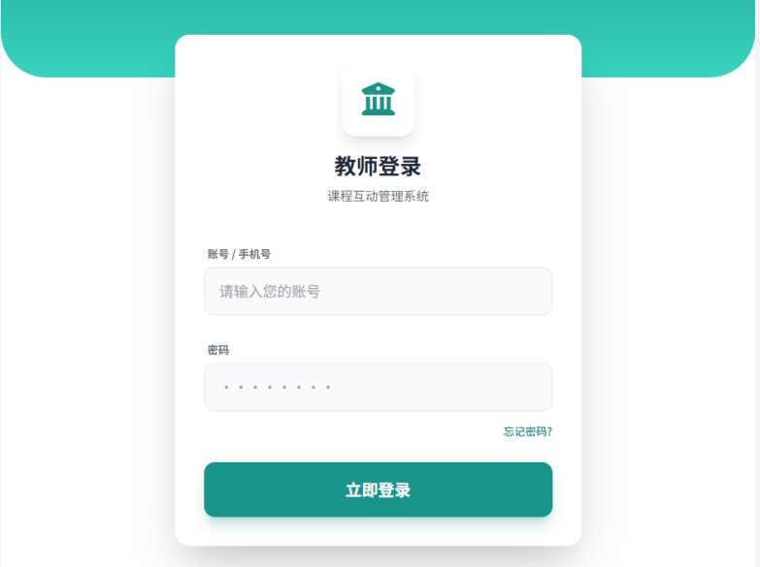

app:

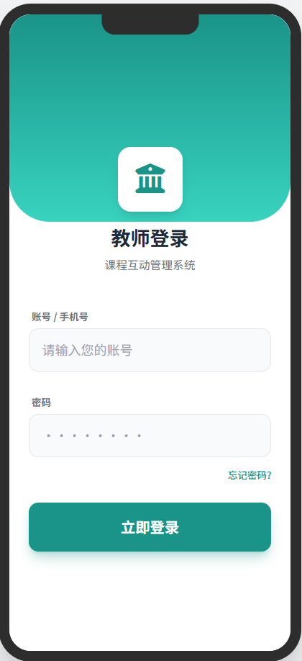

|  |  |
| --- | --- |
| index.html | 首页 |

web:

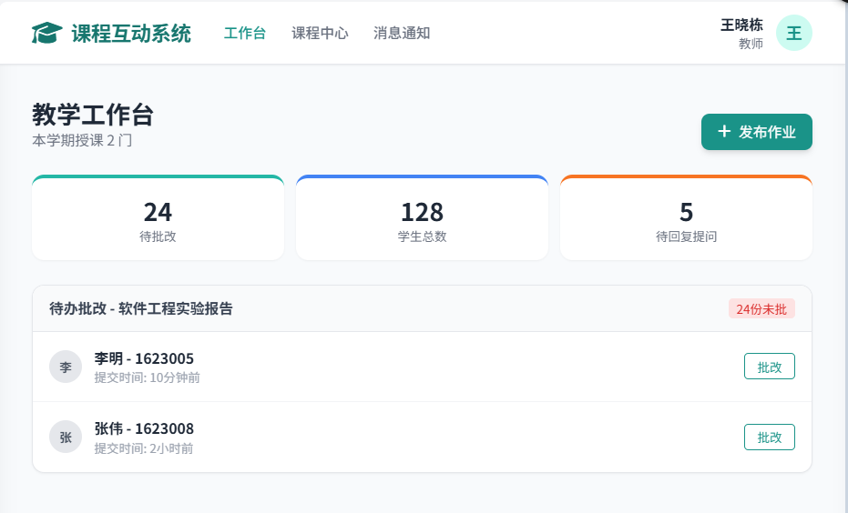

app:

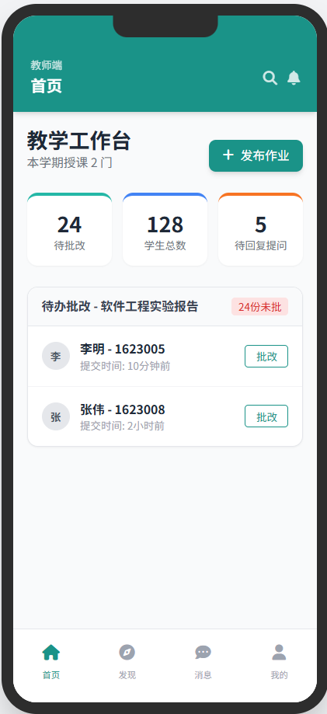

|  |  |
| --- | --- |
| manageStudent.html | 管理学生账号页面 |
| resultSearchStudent.html | 查询学生结果页面 |

web:

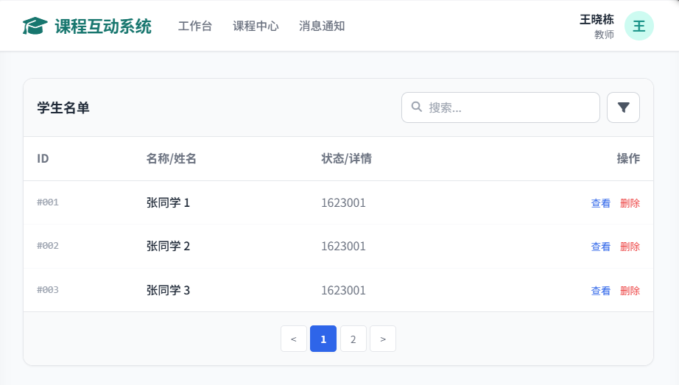

app:

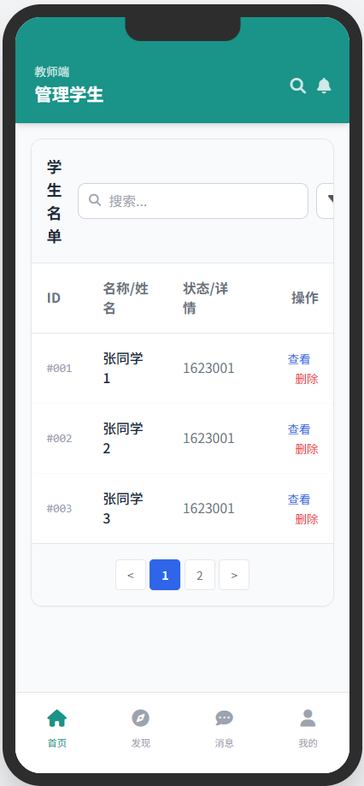

|  |  |
| --- | --- |
| createAssignment.html | 发布作业页面 |

web:

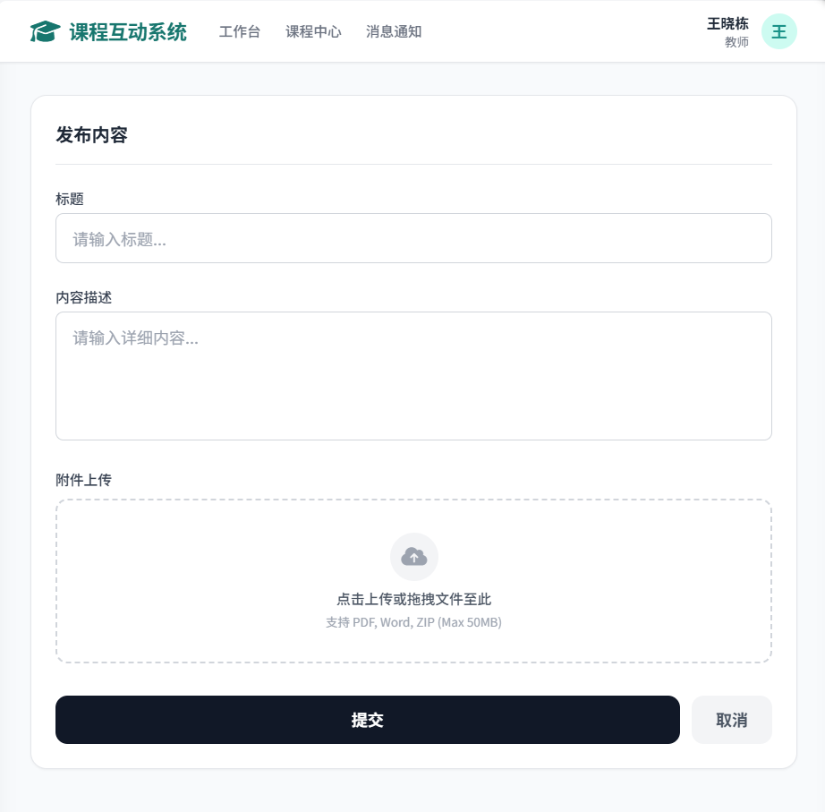

app:

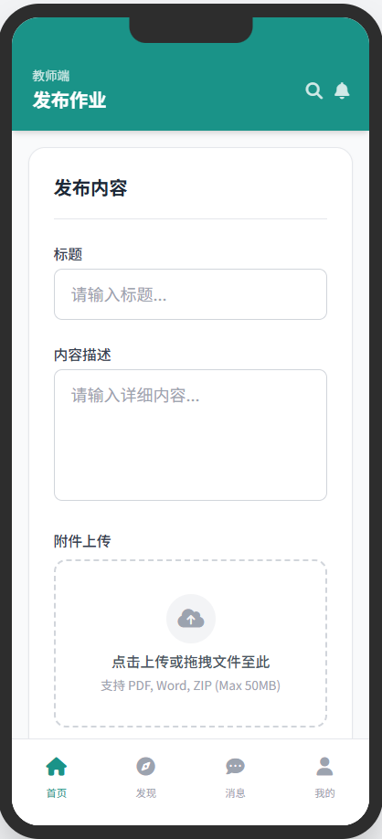

|  |  |
| --- | --- |
| correctAssignment.html | 批改作业页面 |

web:

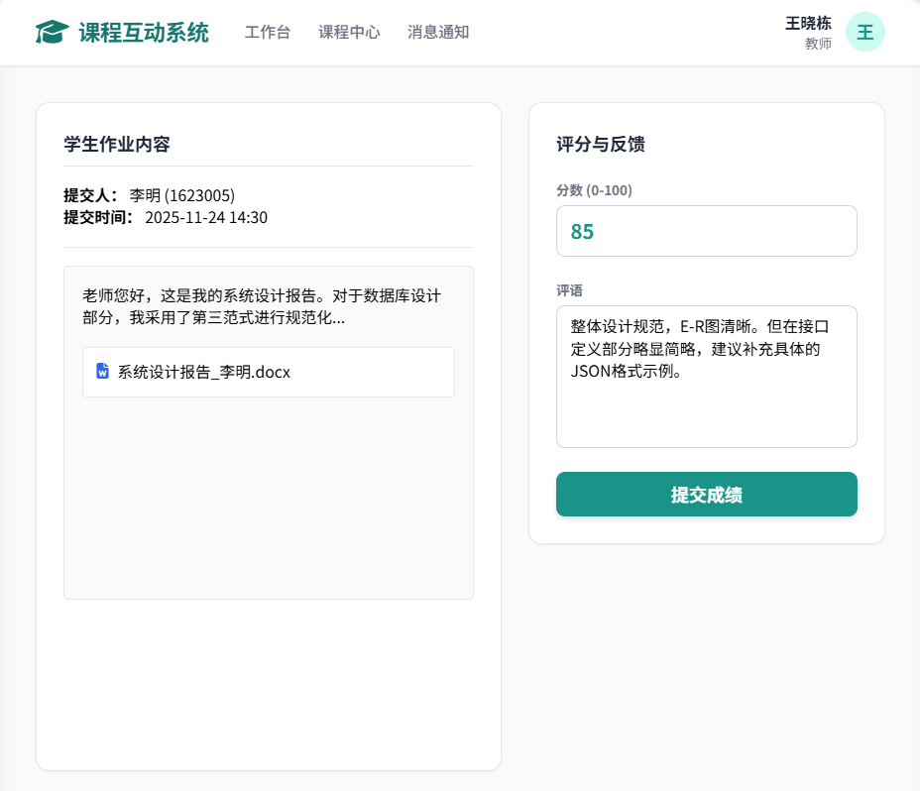

app:

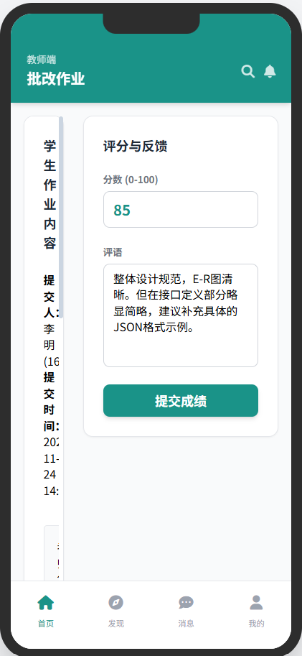

## 3、AcademicOfficer类

|  |  |
| --- | --- |
| signin.html | 登录界面 |

web:

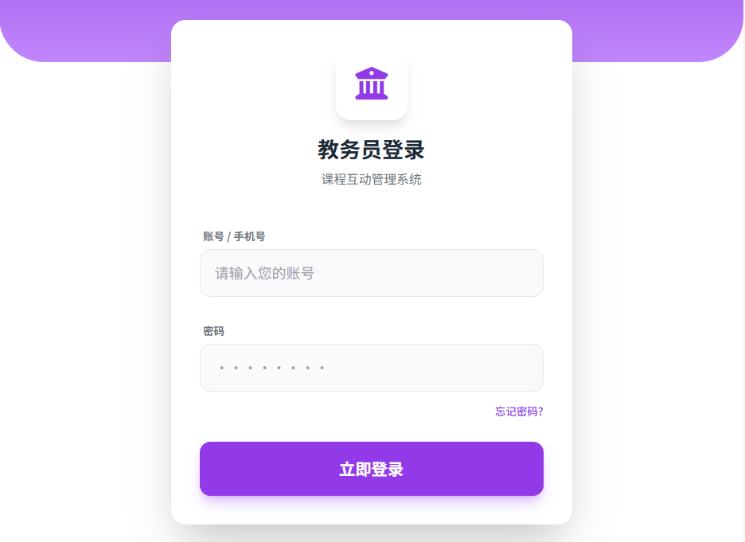

app:

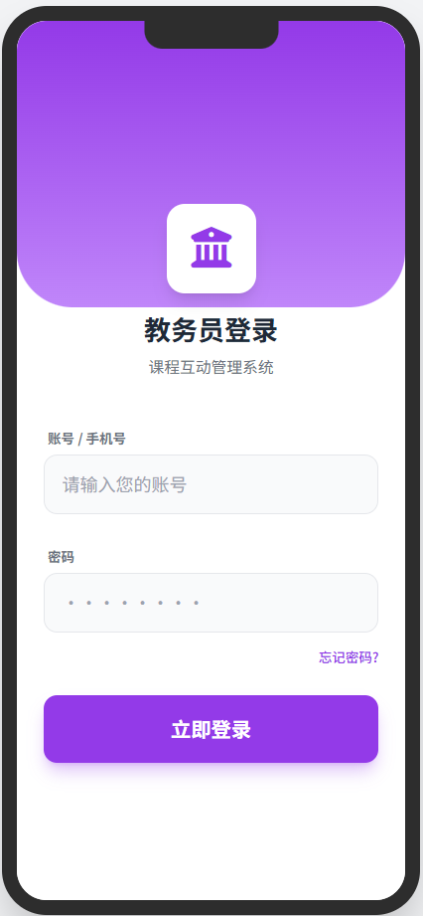

|  |  |
| --- | --- |
| index.html | 首页 |

web:

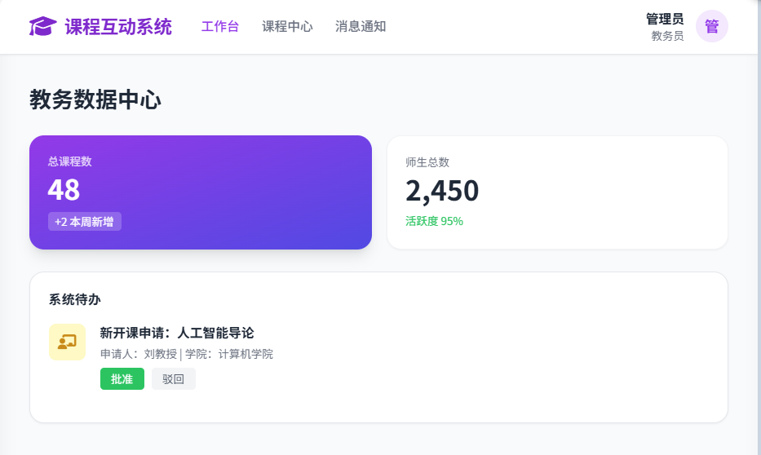

app:

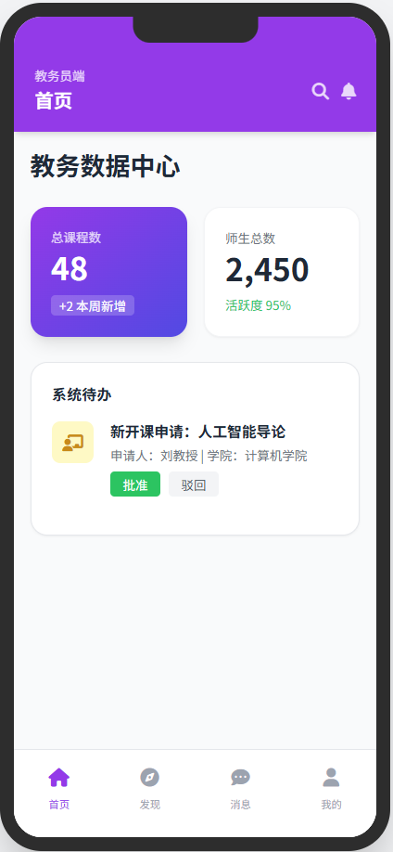

|  |  |
| --- | --- |
| manageStudent.html | 管理学生账号页面 |
| resultSearchStudent.html | 查询学生结果页面 |

web:

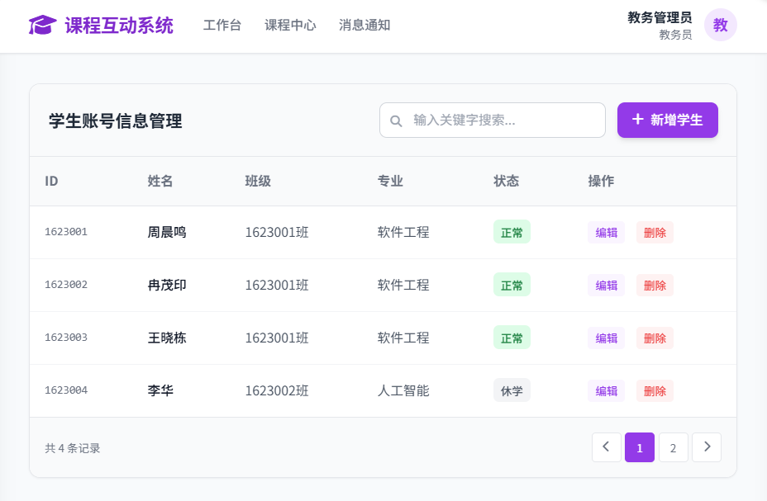

app:

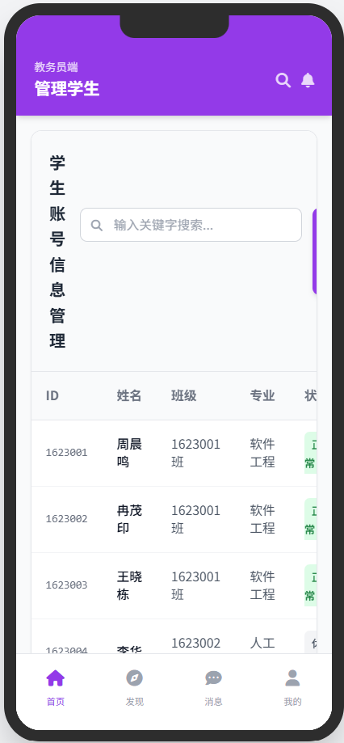

|  |  |
| --- | --- |
| manageTeacher.html | 管理教师账号页面 |
| resultSearchTeacher.html | 查询教师结果页面 |

web:

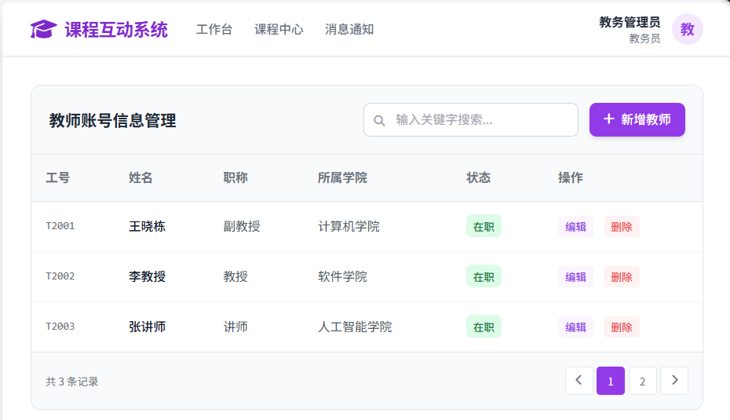

app:

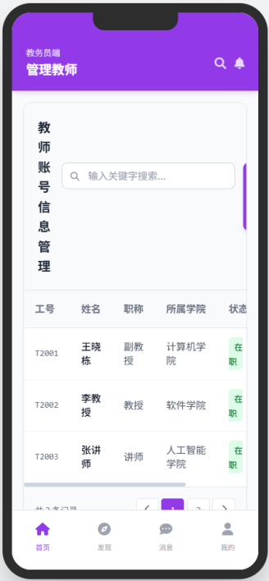

|  |  |
| --- | --- |
| resultSearchCourse.html | 查询课程结果页面 |

web:

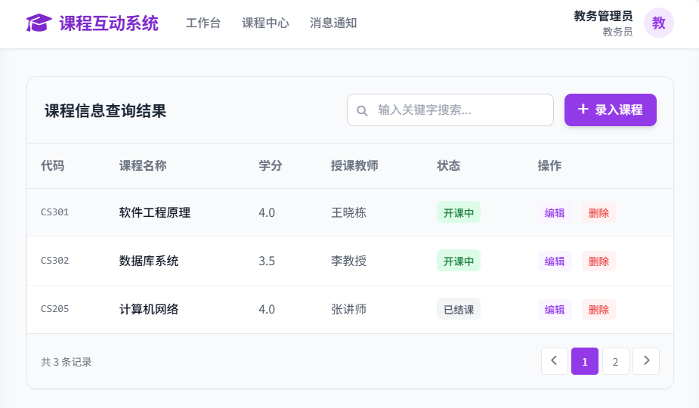

app:

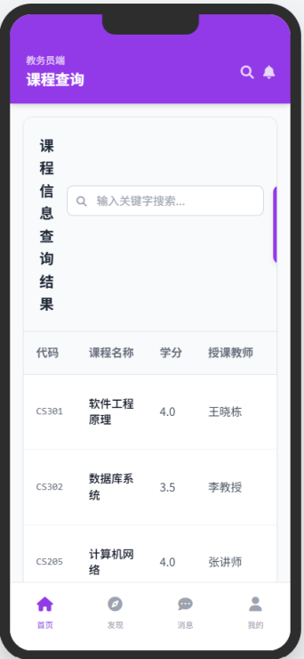

## 4、**CourseInfo**类

|  |  |
| --- | --- |
| AddCourseInfo.html | 课程信息发布页面 |

web:

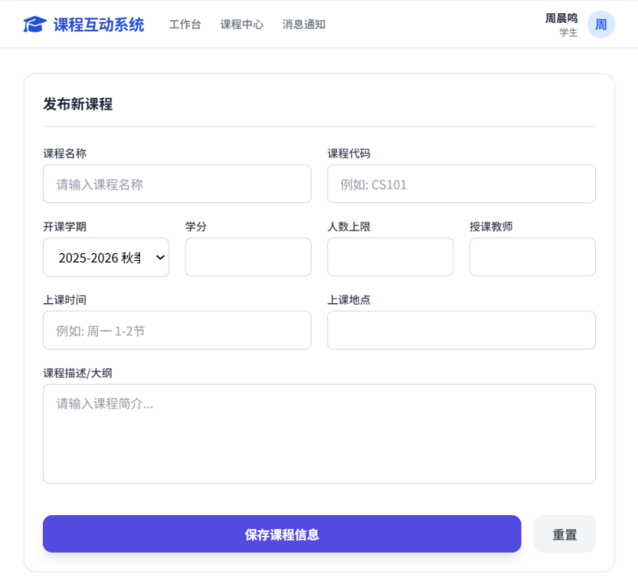

app:

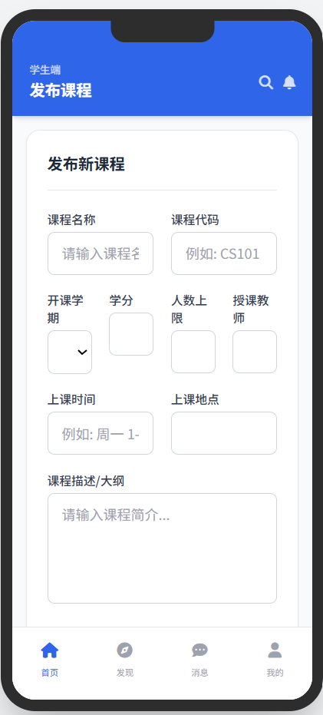

|  |  |
| --- | --- |
| EditCourseInfo.html | 课程信息编辑页面 |

web:

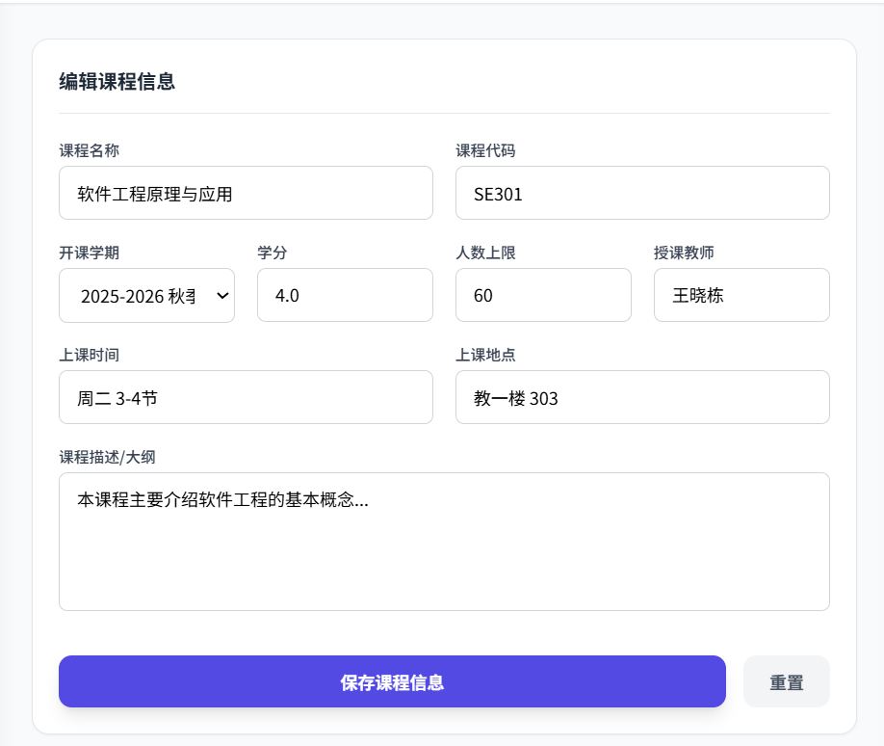

app:

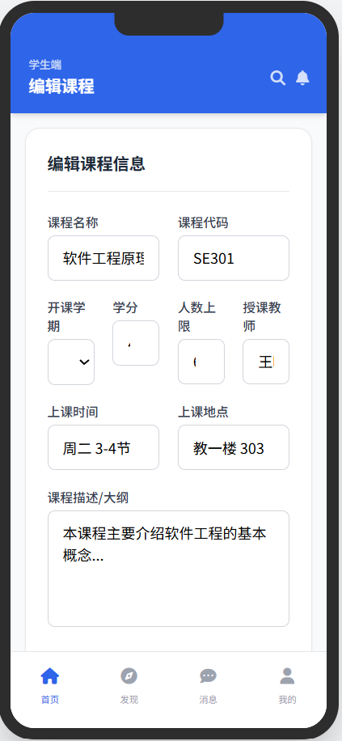

|  |  |
| --- | --- |
| SearchCourseInfo.html | 课程信息查询页面 |

web:

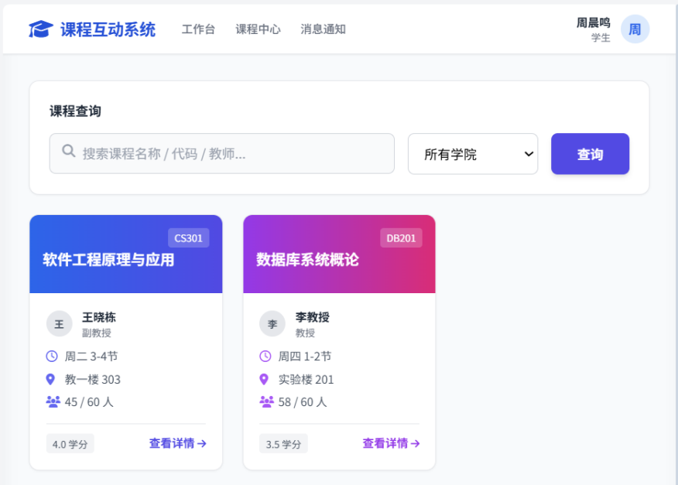

app:

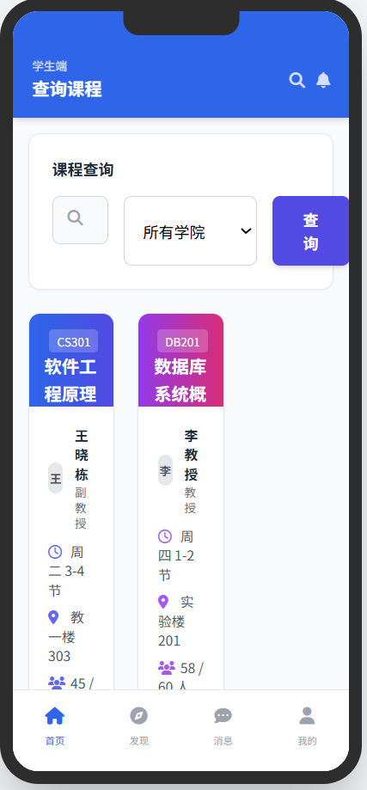

|  |  |
| --- | --- |
| DisplayCourseInfo.html | 课程信息详情页面 |

web:

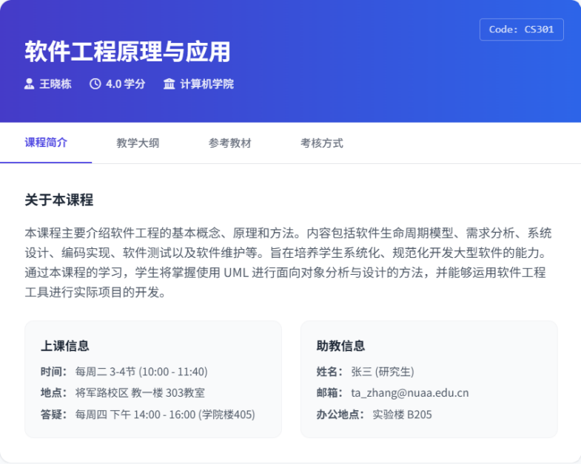

app:

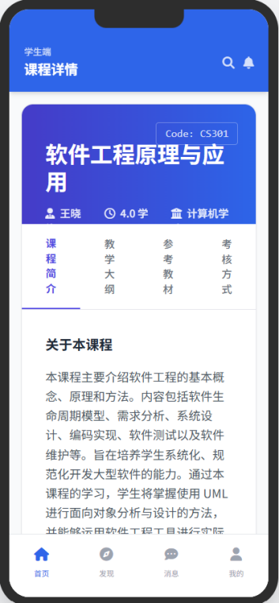

|  |  |
| --- | --- |
| ManagementCoruseInfo.html | 课程信息管理页面 |

web:

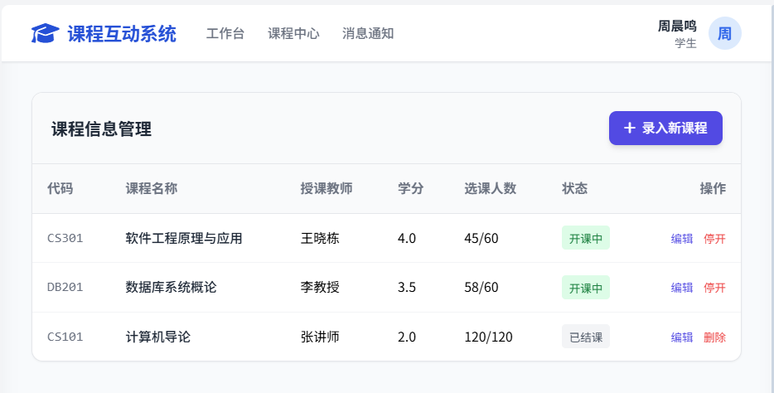

app:

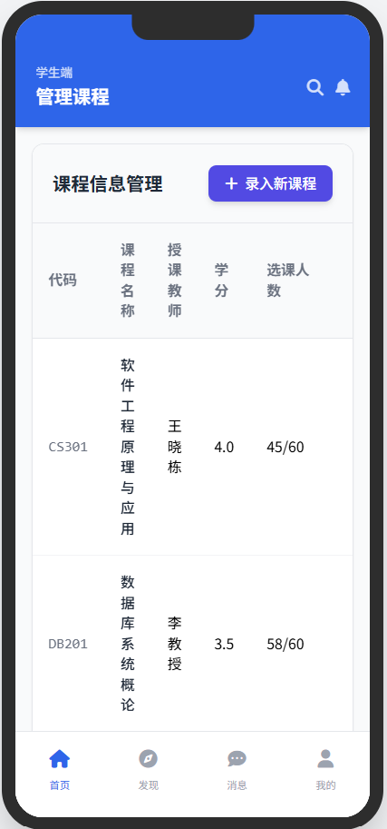

## 5、AssignmentInfo类

|  |  |
| --- | --- |
| AddAssignmentInfo.html | 作业发布页面 |
| EditAssignmentInfo.html | 作业编辑页面 |
| SearchAssignmentInfo.html | 作业查询页面 |
| DisplayAssignmentInfo.html | 作业详情页面 |

web:

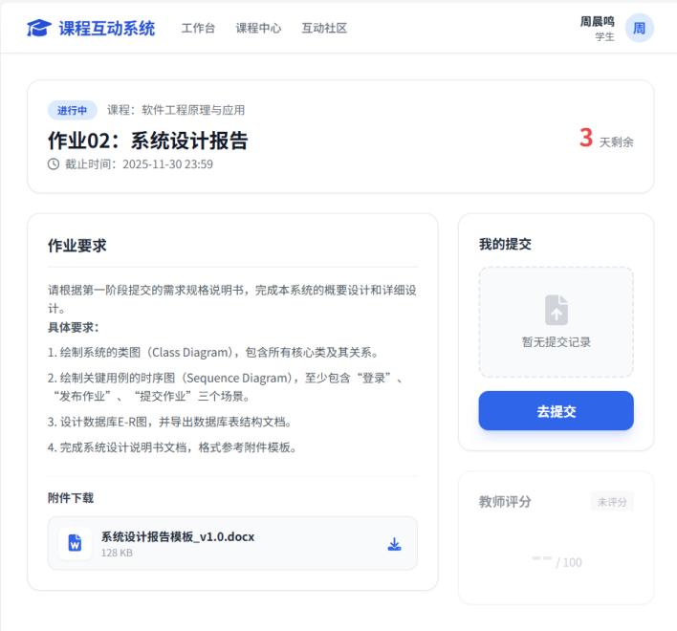

app:

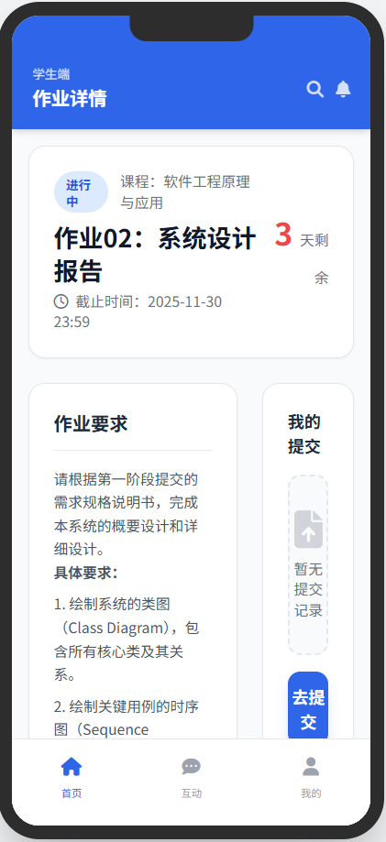

## 6、AssignmentAnswer类

|  |  |
| --- | --- |
| AddAssignmentAnswer.html | 作业答案提交页面 |
| SearchAssignmentAnswer.html | 作业答案查询页面 |
| EditAssignmentAnswer.html | 作业答案编辑页面 |
| DisplayAssignmentAnswer.html | 作业答案详情页面 |
| DeleteAssignmentAnswer.html | 作业答案删除页面 |
| ManageAssignmentAnswer.html | 作业答案管理页面 |
| CorrectAssignmentAnswer.html | 作业答案批改页面 |

web:

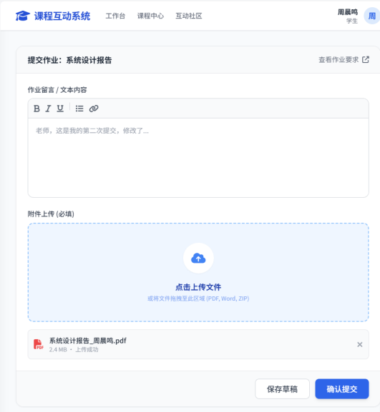

app:

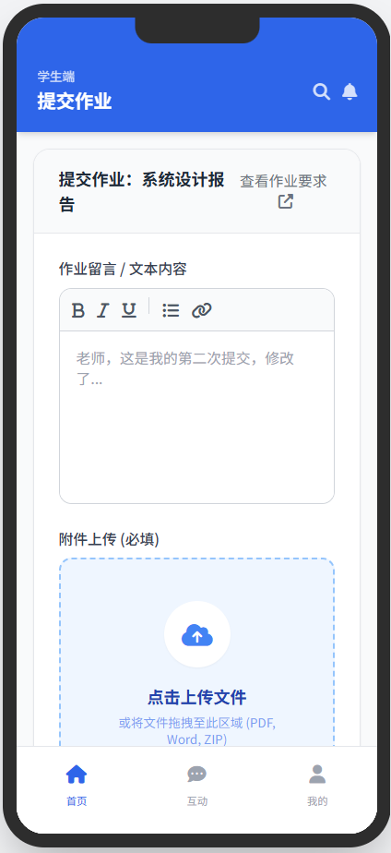

## 7、Feedback类

|  |  |
| --- | --- |
| AddFeedback.html | 反馈发布页面 |
| EditFeedback.html | 反馈编辑页面 |

web:

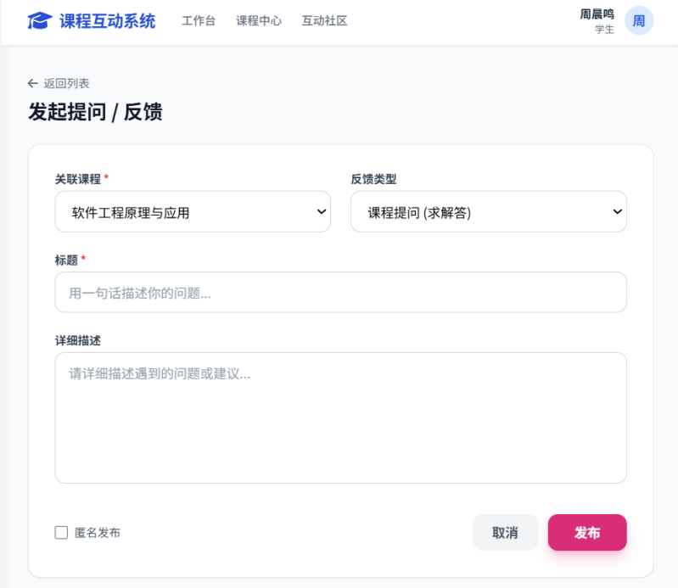

app:

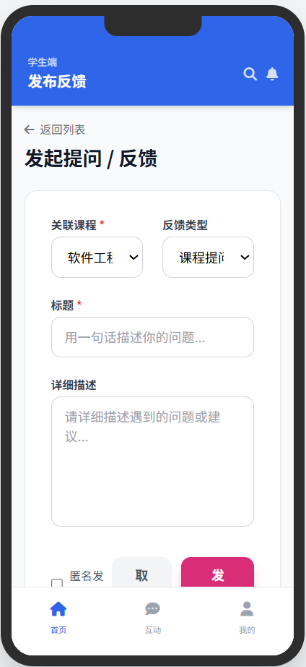

|  |  |
| --- | --- |
| SearchFeedback.html | 反馈查询页面 |

web:

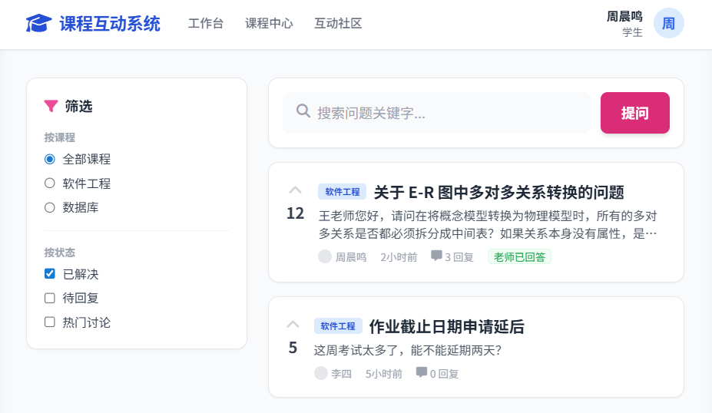

app:

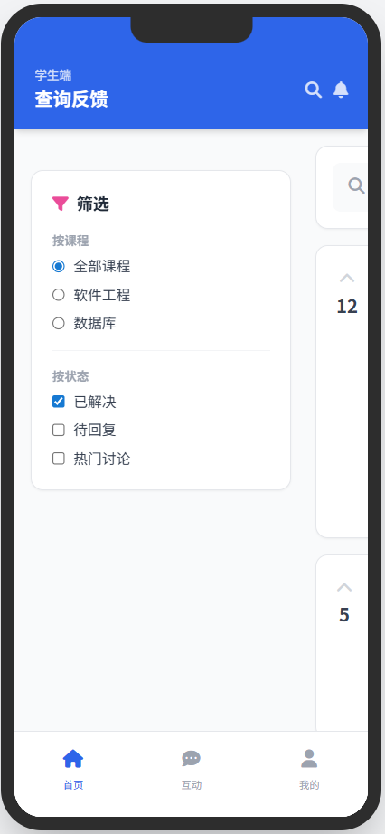

|  |  |
| --- | --- |
| DisplayFeedback.html | 反馈详情页面 |

web:

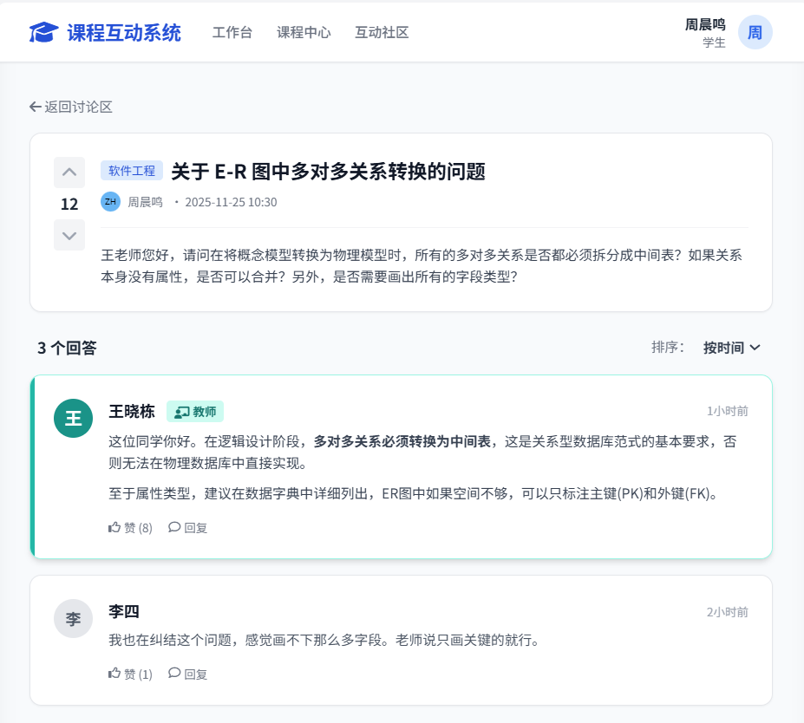

app:

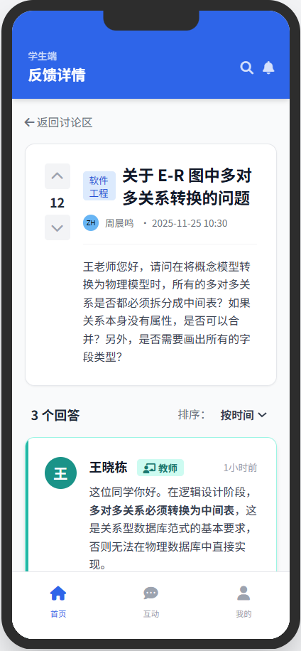

## 8、Response类

|  |  |
| --- | --- |
| AddResponse.html | 答疑发布页面 |

web:

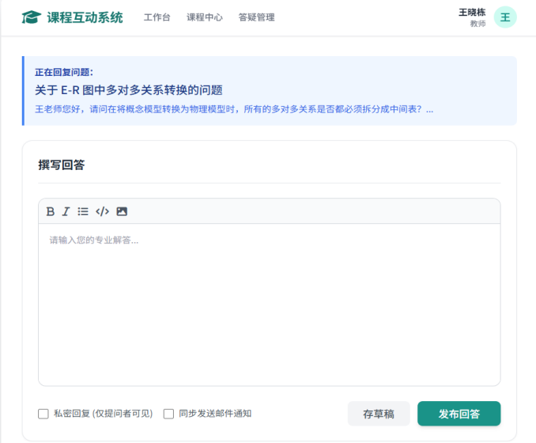

app:

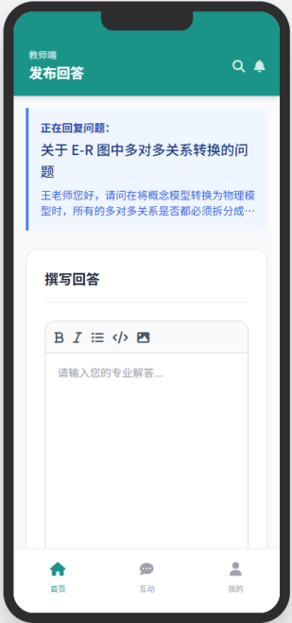

|  |  |
| --- | --- |
| SearchResponse.html | 答疑查询页面 |

web:

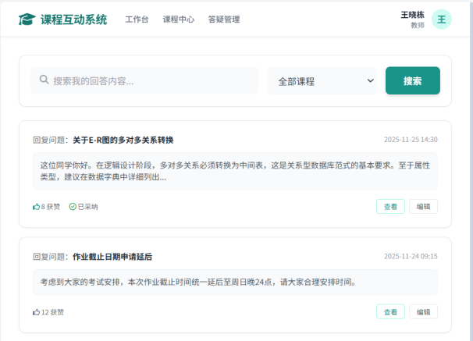

app:

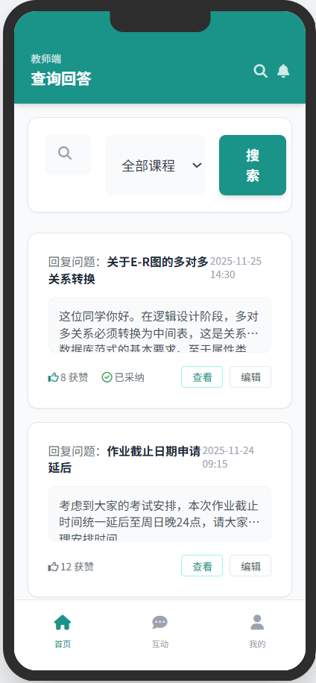

|  |  |
| --- | --- |
| EditResponse.html | 答疑编辑页面 |

web:

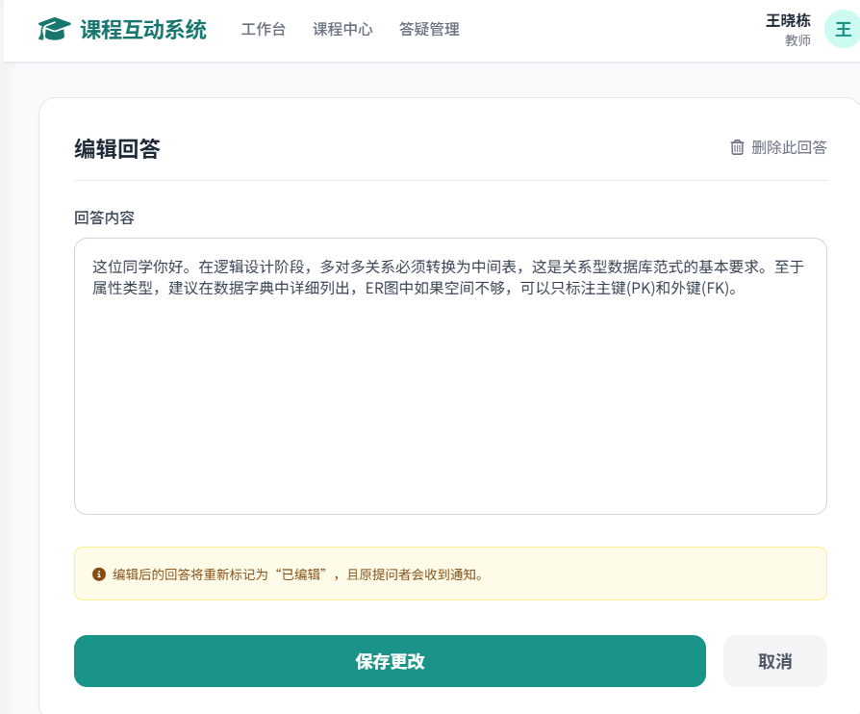

app:

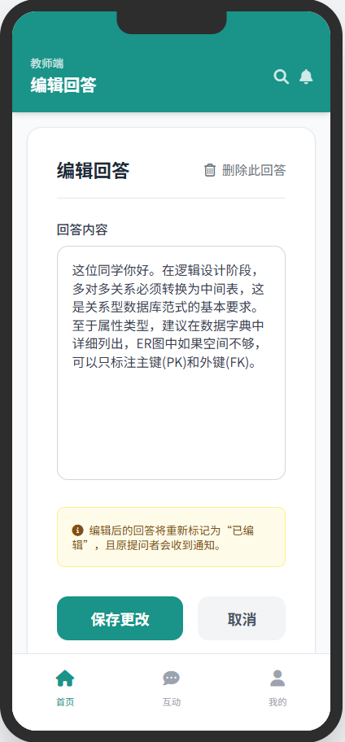

|  |  |
| --- | --- |
| DisplayResponse.html | 答疑详情页面 |

web:

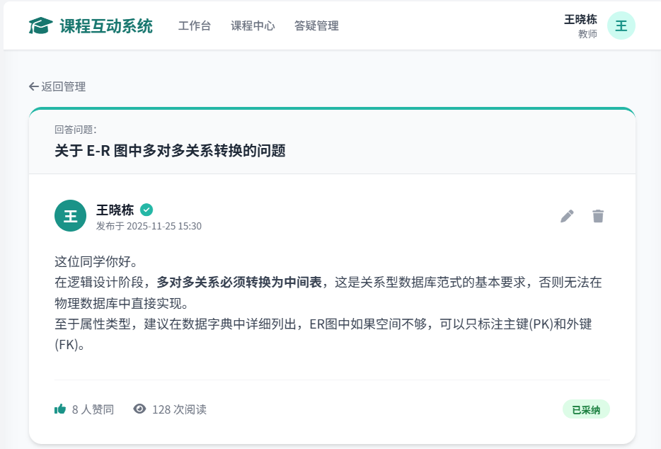

app:

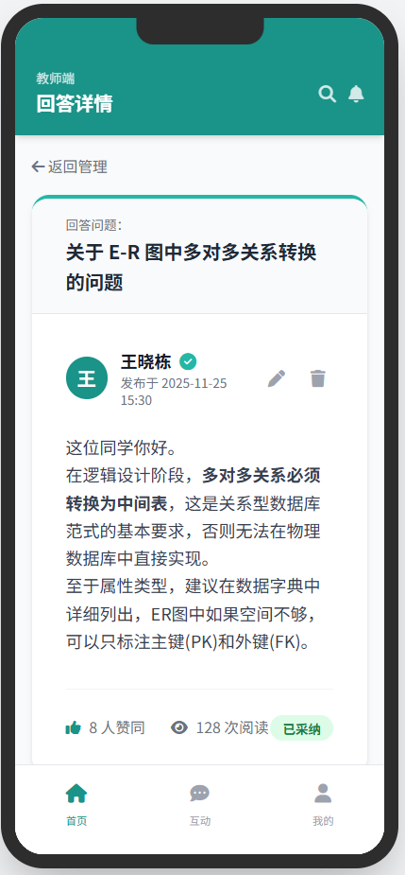

# 三、事务逻辑设计

## 1、Student类

登录处理

Procedure login

Begin

choose the method of login

If (choose the Account password login) then

get the phonenumber and password from signin.html

find the phonenumber and password in the database

If (phonenumber not found) or (phonenumber exist but inputPassWord != Password in database) then

display error hint

Else

goto index.html (Student Homepage)

End if

End if

End login

注册处理

Procedure signup

Begin

get the new_student's info (RealName, StudentNumber, PhoneNumber, Password) from signupStudent.html

find the StudentNumber or PhoneNumber in the database

If (the StudentNumber or PhoneNumber existed in the database) then

show error hint

Else

send the verification to the user with SMS

get and check the verification from signupStudent.html

If (the verification is not correct) then

show error hint and let the user try again

Else

add student's info to database

goto signin.html

End if

End if

End signup

修改个人信息处理

Procedure changeStudentInfo

Begin

get the changed student_info (PhoneNumber, Email, Introduction) from changeStudentInfo.html

find the student and the student's info in database

update the new info into database

display success message

goto getStudentInfo.html

End changeStudentInfo

忘记密码重置密码处理

Procedure forgetPassword

Begin

get the student's phonenumber from forgetPassword.html

find the student's phonenumber in the database

If (the student's phonenumber is existed) then

send the verification to the user with SMS

get and check the verification code

If (the verification is correct) then

show the set_new_password page

get two new_passwords inputted by the user

If (the two new_passwords are the same) then

update the old_password to the new_password in database

goto signin.html

Else

show error hint

End if

Else

show error hint

End if

Else

show error hint

End if

End forgetPassword

注销账号处理

Procedure cancelStudent

Begin

get the cancelStudent submit from getStudentInfo.html

show cancelStudent.html

get the confirmation from cancelStudent.html

If (the result is yes) then

find the student in database

set the account status to "cancelled" or delete from database

goto signin.html

Else

return to getStudentInfo.html

End if

End cancelStudent

## 2、Teacher类

登录处理

Procedure login

Begin

get the phonenumber and password from signin.html (Teacher View)

find the phonenumber and password in the database

If (phonenumber not found) or (password incorrect) then

display error hint

Else

goto index.html (Teacher Homepage)

End if

End login

教师用户账号

Procedure manageTeacherAccount

Begin

get the request to view or edit profile

If (view profile) then

retrieve teacher info from database

display info on Interface

Else if (edit profile) then

get new info from input fields

update teacher info in database

display success message

End if

End manageTeacherAccount

教师作业处理

Procedure TeacherAssignmentProcess

Begin

choose the action type

If (action is Publish Assignment) then

call createAssignment Procedure

Else if (action is Correct Assignment) then

call correctAssignmentAnswer Procedure

End if

End TeacherAssignmentProcess

## 3、AcademicOfficer类

登录处理

Procedure login

Begin

get the account and password from signin.html (Officer View)

verify credentials in database

If (credentials are valid) then

goto index.html (Officer Homepage)

Else

display error hint

End if

End login

教务员用户账号

Procedure manageOfficerAccount

Begin

retrieve officer details from database

display details on dashboard

If (request to update info) then

validate and update new info in database

End if

End manageOfficerAccount

教务员查询处理

Procedure OfficerSearch

Begin

get search keywords (Student Name, Teacher Name, or Course Name)

query database for matching records

If (records found) then

display results in resultSearchStudent.html, resultSearchTeacher.html or resultSearchCourse.html

Else

display "No records found" hint

End if

End OfficerSearch

教务员管理处理

Procedure OfficerManage

Begin

choose management target (Student, Teacher, Course)

If (target is Student) then

goto manageStudent.html

perform Add, Edit, or Delete operation on Student Data

Else if (target is Teacher) then

goto manageTeacher.html

perform Add, Edit, or Delete operation on Teacher Data

End if

End OfficerManage

## 4、CourseInfo类

创建课程信息

Procedure createCourse

Begin

get course details (Name, Code, Credits, Teacher, Time, Location) from AddCourseInfo.html

If (Course Code already exists) then

display error hint

Else

insert new course record into database

display success message

goto ManagementCoruseInfo.html

End if

End createCourse

删除课程信息

Procedure deleteCourse

Begin

get the CourseID from ManagementCoruseInfo.html

find the course in the database

If (course exists) then

delete the course record from database

display success message

refresh ManagementCoruseInfo.html

Else

display error message

End if

End deleteCourse

修改课程信息

Procedure modifyCourse

Begin

get the CourseID and new details from EditCourseInfo.html

find the course in the database

update the course record with new details

display success message

goto ManagementCoruseInfo.html

End modifyCourse

查询课程信息

Procedure searchCourse

Begin

get the search keyword from SearchCourseInfo.html

query database for matching courses

display results on resultSearchCourse.html

If (user clicks specific course) then

goto DisplayCourseInfo.html

End if

End searchCourse

## 5、AssignmentInfo类

创建作业信息

Procedure createAssignment

Begin

get assignment details (Title, Content, Deadline, Attachment) from createAssignment.html

If (Title or Content is empty) then

display error hint

Else

record the current time as PublishTime

insert assignment record into database

display success message

return to index.html

End if

End createAssignment

删除作业信息

Procedure deleteAssignment

Begin

get the AssignmentID

check if the user is the creator (Teacher)

If (true) then

delete assignment record from database

display success message

Else

display permission denied hint

End if

End deleteAssignment

修改课程信息

Procedure modifyAssignment

Begin

get the AssignmentID and new details from EditAssignmentInfo.html

check if the current time is before Deadline

If (true) then

update assignment record in database

display success message

Else

display error hint "Cannot modify after deadline"

End if

End modifyAssignment

查询课程信息

Procedure searchAssignment

Begin

get the CourseID

retrieve all assignments associated with CourseID from database

display list in SearchAssignmentInfo.html

If (select an assignment) then

goto DisplayAssignmentInfo.html

End if

End searchAssignment

## 6、AssignmentAnswer类

创建作业答案

Procedure submitAssignmentAnswer

Begin

get the answer content and attachment from AddAssignmentAnswer.html

get StudentID and AssignmentID

If (current time > Assignment Deadline) then

display error hint "Submission deadline passed"

Else

insert or update answer record in database

record SubmissionTime

display success message

End if

End submitAssignmentAnswer

删除作业答案

Procedure deleteAssignmentAnswer

Begin

get AnswerID from DeleteAssignmentAnswer.html

check if Assignment is still open for submission

If (true) then

delete answer record from database

display success message

Else

display error hint

End if

End deleteAssignmentAnswer

修改作业答案

Procedure modifyAssignmentAnswer

Begin

get new answer content from EditAssignmentAnswer.html

check if Assignment is graded

If (graded) then

display error hint "Cannot modify graded assignment"

Else

update answer record in database

display success message

End if

End modifyAssignmentAnswer

查询作业答案

Procedure searchAssignmentAnswer

Begin

get AssignmentID and StudentID

query database for answer record

If (found) then

display details in DisplayAssignmentAnswer.html

Else

display "No submission" status

End if

End searchAssignmentAnswer

批改作业答案

Procedure correctAssignmentAnswer

Begin

get Score and Comments from CorrectAssignmentAnswer.html

get AnswerID

update answer record with Score and Comments in database

set status to "Graded"

display success message

goto index.html (Teacher Workbench)

End correctAssignmentAnswer

## 7、Feedback类

增加反馈信息

Procedure addFeedback

Begin

If (login() = true) then

get feedback content, title, and type from AddFeedback.html

get CourseID

insert feedback record into database

record PublishTime

display success message

goto SearchFeedback.html

End if

End addFeedback

删除反馈信息

Procedure deleteFeedback

Begin

get FeedbackID

check if user is the author or Admin

If (true) then

delete feedback record from database

display success message

End if

End deleteFeedback

查询反馈信息

Procedure searchFeedback

Begin

get filter criteria (Course, Keyword) from SearchFeedback.html

query database for matching feedbacks

display results list

If (select specific feedback) then

goto DisplayFeedback.html

End if

End searchFeedback

修改反馈信息

Procedure modifyFeedback

Begin

get FeedbackID and new content from EditFeedback.html

update feedback record in database

display success message

goto DisplayFeedback.html

End modifyFeedback

## 8、Response类

增加回答信息

Procedure addResponse

Begin

get response content from AddResponse.html

get FeedbackID and UserID (Teacher or Student)

insert response record into database

display success message

refresh DisplayFeedback.html

End addResponse

删除回答信息

Procedure deleteResponse

Begin

get ResponseID

check permissions (Author or Teacher)

If (authorized) then

delete response record from database

display hint

End if

End deleteResponse

修改回答信息

Procedure modifyResponse

Begin

get ResponseID and new content from EditResponse.html

update response record in database

mark response as "Edited"

display success message

End modifyResponse

查询回答信息

Procedure searchResponse

Begin

get UserID (Teacher)

query database for all responses made by the teacher

display list in SearchResponse.html

allow filter by Course or Time

End searchResponse

# 四、数据库设计

## User类

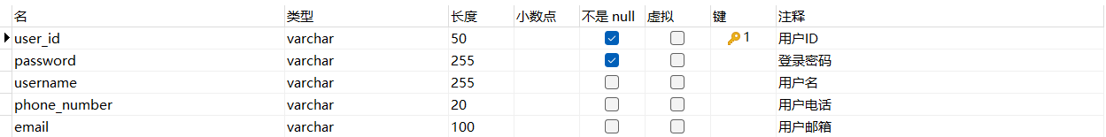

## Student类

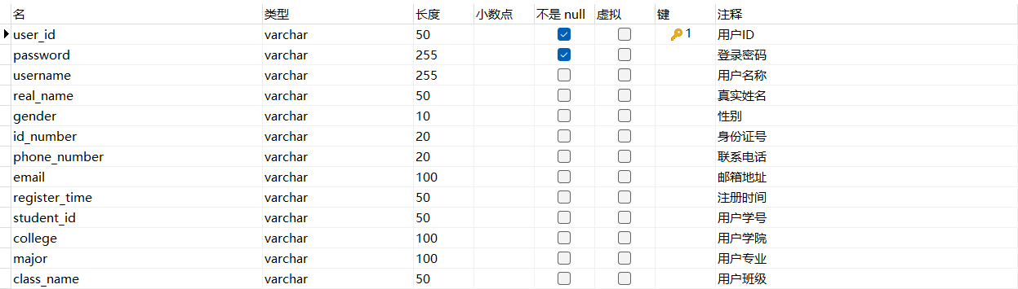

## Teacher类

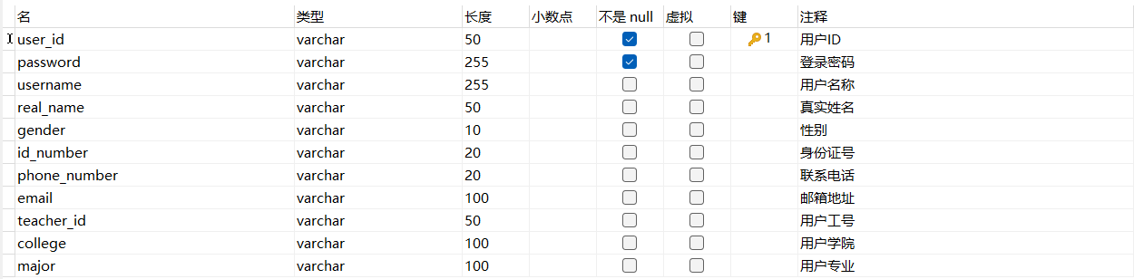

## AcademicOfficer类

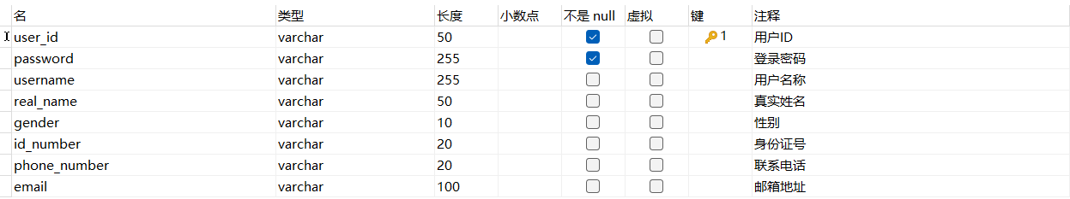

## CourseInfo类

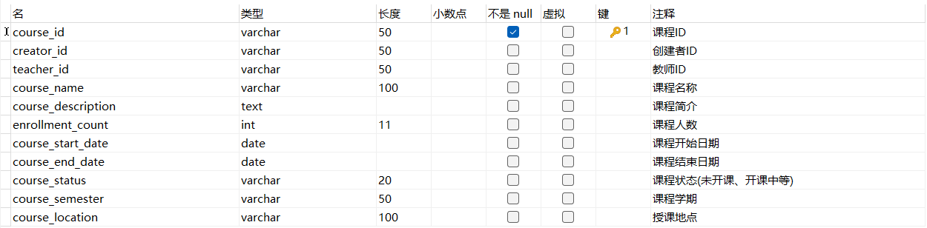

## AssignmentInfo类

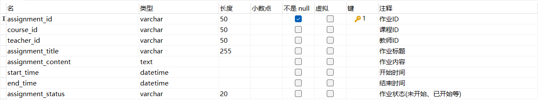

## AssignmentAnswer类

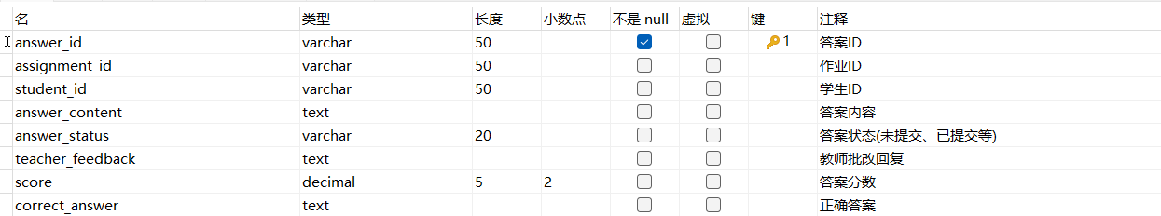

## Feedback类

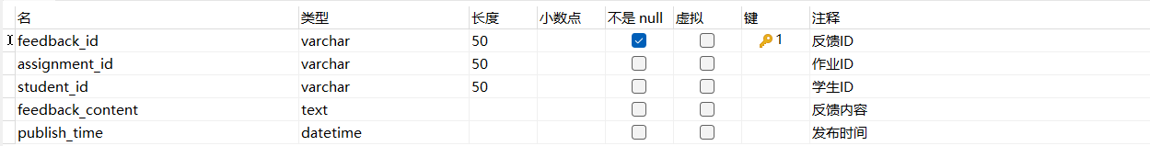

## 9、Response类

